Section 7. Marketing Information—4Ps

Market research must be conducted by HackerNest to help solve marketing problems and make the business more successful. Firstly, HackerNest needs to collect primary data, which is data that needs to be collected by the HackerNest itself, or hire a marker research firm to collect. Primary data refers to information that businesses gather that relates specifically to the company’s problems. HackerNest needs to know the issues most South Koreans want to address at hackathons, what people like or dislike about HackerNest’s tech social and hackathons, who is most interested in attending HackerNest’s tech social and hackathons, and who the company’s competitors are. HackerNest can ask Seoul National University to be its test markets for hackathons (See Appendix F, Figure 1 for Location of Seoul National University). HackerNest can host a small-scaled hackathon that lasts 24 hours on campus and gather feedback from the attendants. Because it is very expensive to conduct a test market research, HackerNest should ask Seoul National University for sponsorship, such as venue, food, and accommodation. HackerNest should also recruit university students to volunteer and mentor at this event. During the event, HackerNest should observe what the attendants enjoy the most and dislike the most. After the event, HackerNest can give each attendant, volunteer and mentor a likert scale survey to fill in (See Appendix F, Figure 2 for Likert Scale Survey). Based on the likert scale survey, HackerNest can make improvements to their primary product. To test the effectiveness of tech socials, HackerNest can conduct a focus group research. To be more specific, HackerNest can arrange a meeting for potential tech social attendants such as evangelists and start-up CEOs. During the meeting, HackerNest can ask the focus group what they like or dislike about the tech socials they have been to, and what they want HackerNest can do to make their tech-social experience better. Then, the discussion can go into great detail about the venue to host the tech-social, the entrance requirement and pricing, and promotion consideration. Since HackerNest—Seoul is not HackerNest’s first foreign subsidy, HackerNest can use its internal information sources, such as past business analysis on its hackathon and tech social feedback, inventory data, advertising results, and production statistics to determine the product development, pricing, place, and promotion for HackerNest’s subsidy in Seoul (See Appendix F, Figure 3 for Hackathon Feedback).

In addition, HackerNest should gather secondary data, which is data collected from websites, databases, books, periodicals and indexes, to thoroughly solve marketing problems. HackerNest can use the Organizer Guide provided by Major League Hacking to manage time and organize the hackathon (“The MLH Hackathon Organizer Guide”). To allocate budget, HackerNest can refer to the “Template Hackathon Budget”, which is also provided by Major League Hacking (See Appendix F, Figure 4 for Major League Hacking Example Budget). However, HackerNest must consider the currency exchange rate and the cost of meals, facilities, emergency service, and transportation in South Korea. Most hackathons have a theme. The participants come to a hackathon to develop a hardware or a software that solves issues related to the theme. HackerNest’s target market should be the millennials in South Korea. Millennials are the generation reaching young adulthood in the early 21st century. They are exposed to technology, and they have enough expertise and experience to create a prototype to solve a specific issue within a given amount of time. To determine the theme of each hackathon, HackerNest can research about the critical problems that the millennials care about. Tanza Loudenback, in her article titled “The 10 most Critical Problems in the World, according to Millennials” published on Business Insider, outlines the most concerning issues among the millennials. The top three most concerning issues are climate change and destruction of natural resources, large scale conflict and wars, and religious conflict (Loudenback).

Based on the primary and secondary market research, HackerNest’s first hackathon in South Korea can be titled Environment Hack (See Appendix F, Figure 5 for Picture of Hackathon). This hackathon is related to the environment, and it will bring together high schoolers, college students, and millennials in the work force to tackle pressing environmental and natural challenges in South Korea. To increase the publicity and awareness of this hackathon, HackerNest can partner with the Ministry of Environment in South Korea and United Nation Environment Programme. Comparing to North America, hackathons are not as well developed or well known in South Korea. Therefore, HackerNest should open 350 spots for local participants, and invite 50 famous hackers from North America to assist those local participants. Most hackathons last 24 to 48 hours. Environment Hack should last 36 hours in total. This include time for opening, hacking, judging, and closing. During the hackathon, meals and snacks need to be provided. Since Koreans love spicy food, spicy Korean food and kimchi must be provided. Rice, Doenjang, and gochujang, and an addition of one meat dish, one vegetarian option, and one western dish should also be offered to suffice the need. It is a tradition to hand out souvenir shirts to participants and volunteers at each hackathon. Fortunately, because the South Koreans today seem to prefer clothes inspired by modern western styles, HackerNest can use the shirt design from past hackathons and make few minor changes. (See Appendix F, Figure 6 for Current Shirt Design). At the end of Environment Hack, prizes and trophies should be given to the top teams. High value and cash prizes are likely to discourage collaboration between teams. Therefore, instead of cash prizes, HackerNest can give out mentorship opportunities and IT products provided by sponsors to winning teams (See Appendix F, Figure 7 for Prize Examples). Something HackerNest should keep in mind is that all prizes should be wrapped and branded with HackerNest’s and sponsors’ logos. Prizes shouldn’t be given in multiples of 4 because number 4 is considered unlucky. Additionally, most prizes should be wrapped in red, yellow, pink, or “Seoul Blue” as these colors denote luck and happiness in South Korea (“South Korea Gift Giving Customs”).

More than six months prior to Environment Hack, HackerNest should lock down a venue. Having a confirmed venue will prove to potential sponsors and attendees that HackerNest is serious about hosting a great event. An on-campus venue is HackerNest’s best option because it’s usually free, and hosting Environment Hack on campus will attract many student attendees and volunteers. HackerNest can use the Venue Checklist provided by Major League Hacking to prepare for the venue (See Appendix F, Figure 8 for Venue Checklist). This checklist contains everything that’s needed for Environment Hack. HackerNest should approach to Hanyang University for the venue (See Appendix F, Figure 9 for Location of Hanyang University). Hanyang University locates in the heart of Seoul, it is surrounded by 2 bus stations and 4 subway stations, so, the transportation to the venue is very convenient (“Campus Map and Directions). Environment Hack can be hosted at the Chung Mong-Koo Automotive Research Centre (See Appendix F, Figure 10 for Location). This research centre is donated by Hyundai Motor Group to cultivate talent for the green and smart car sectors. (“Hyundai Motor Opens R&D Center in Hanyang University”). Since Environment Hack is targeted to environmental issues, the purpose of the hackathon shares some similarities with the mission of the research center. Additionally, the research centre has enough workspace, dining area, judging rooms, and resting area to accommodate over 400 people (See Appendix F, Figure 11 for Pictures of Chung Mong-Koo Automotive Research Centre).

In addition to the hackathon venue, HackerNest also needs to rent an office space that is used to accommodate full-time employees, host meetings between businesses, and hold tech meetups. HackerNest will be adopting the decentralized strategy since HackerNest’s headquarter is setting up a manufacturing plant in another country and hiring foreign employees. HackerNest’s subsidy in Seoul will be locating at the city’s Central Business District. This area is the centre of Seoul’s most successful business hub, and it has a modern and stylish atmosphere (See Appendix F, Figure 12 for Seoul CBD). The business center has direct access to subway station, subway connection to the Incheon International Airport and the Gimpo Airport. Moreover, it is close to the city hall, embassies, as well as international class hotels and restaurants (See Appendix F, Figure 13 for Office Location). For local employees, it’s convenient to commune to HackerNest’s office. For international employees, or board of executives from the headquarter, HackerNest’s office in Seoul can arrange them to stay at the international class hotels close by (See Appendix F, Figure 14 for Building External Look). HackerNest can rent 6 office suites along with a spacious open co-working space at the business center (See Appendix F, Figure 15 for Picture of Office Suite). The total rental price is approximately 2300000 Korean Won, which is 2050 USD. This price covers the use of conference rooms, business lounge, Wi-Fi, copying facilities, IT support, and videoconferencing equipment (See Appendix F, Figure 16 for Internal Space). Since meetings will be conducted between HackerNest’s headquarter and its subsidy in Seoul, videoconferencing equipment will be used (See Appendix F, Figure 17 for Conference Room). The business lounge is a spacious area (See Appendix F, Figure 18 for Business Lounge). It contains a mini bar and many chairs and tables, and it is big enough to accommodate 100 people for a tech meetup (*Instant Office*).

Hackathons and tech meetups should be free to the public. Therefore, HackerNest needs to fundraise and negotiate with IT businesses in Seoul. Before approaching sponsors, HackerNest need to create a short info packet that explains what HackerNest does, what HackerNest is providing, why HackerNest needs their sponsorship. Since HackerNest doesn’t conduct any profitable business practice, all expenses come from sponsorship. When determining the yearly budget, HackerNest needs to consider the office rental cost, transportation cost for international employees, cost for a hackathon, and cost for 12 monthly tech meetups. According to secondary data on hackathon budget, $45,000 USD would be sufficient to host a hackathon. HackerNest’s only expense for monthly tech meetups is snacks and drinks. The average cost for snacks and drinks is $5 per person. Since each meetup can accommodate up to 100 people, $500 USD is needed to host one tech meetups (“Draft Your Budget”).

Promotion must be conducted to advertise hackathons and tech meetups. Firstly, HackerNest can reach out to student groups and STEM departments on all university campuses in Seoul, and speak to student council about the upcoming hackathon. Secondly, HackerNest can launch a social media campaign. This including creating a Facebook event page, as well as making a Kakao Talk business account (See Appendix F, Figure 19 for Business Models Built on Kakao Talk). Facebook is the most popular social networking service and Kakao Talk is a free mobile messenger that is used by 35 million people (*Yonhap News*). Therefore, HackerNest should definitely consider Facebook and Kakao Talk ads to promote its events (See Appendix F, Figure 20 for Facebook Advertising). These ads must be translated into Korean due to regulations on Use of Foreign Languages in Advertisement (South Korea: Reaching the Consumers). They should contain HackerNest’s or event’s logo, a catchy slogan of the event, colorful and appealing pictures, and a link to the Facebook event page.

Overall, a complete and thorough research needs to be conducted by HackerNest to solve marking problems associated with products, place, prize, and promotion.

Appendix F.

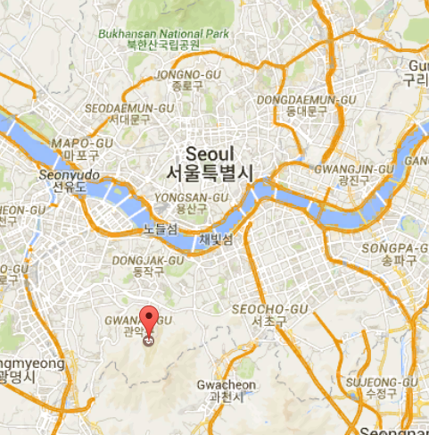

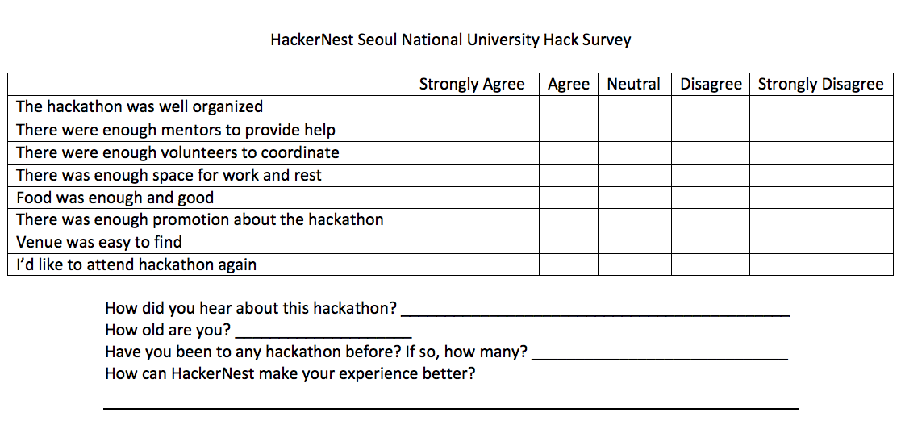Figure 1.

Figure 2.

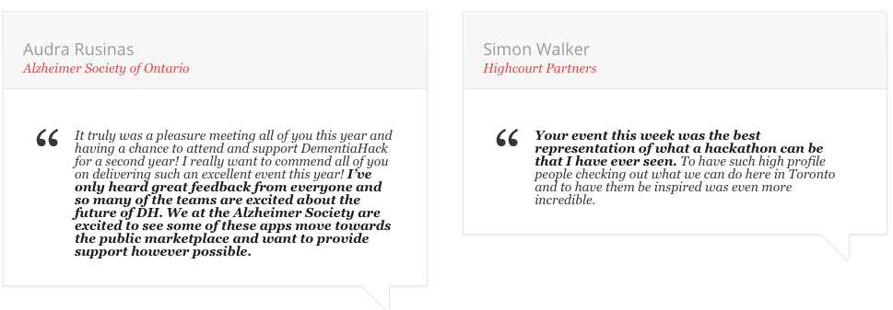

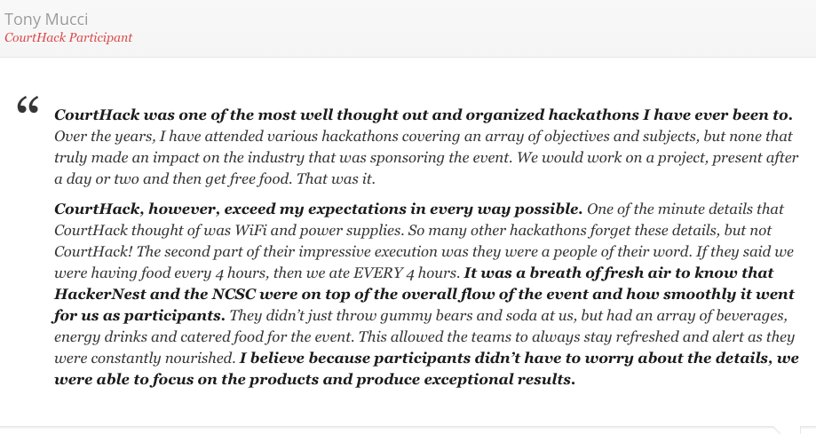

Figure 3.

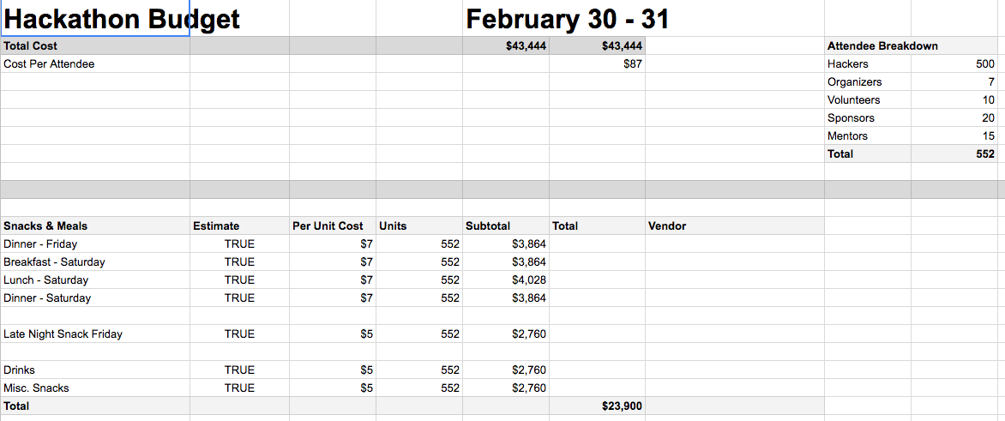

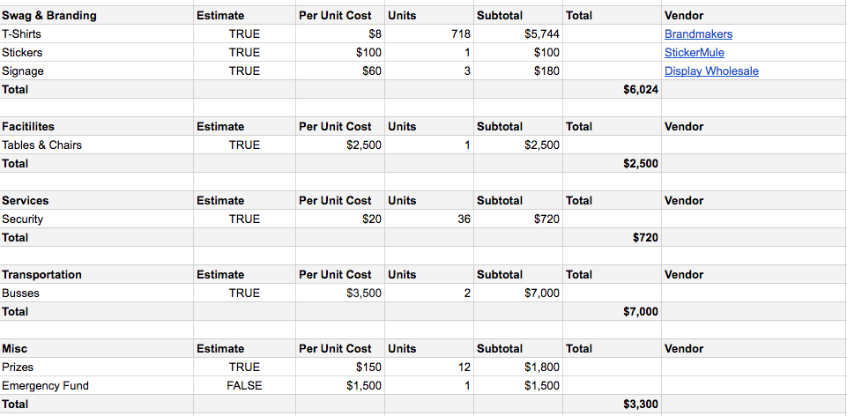

Figure 4.

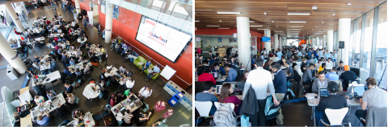

Figure 5.

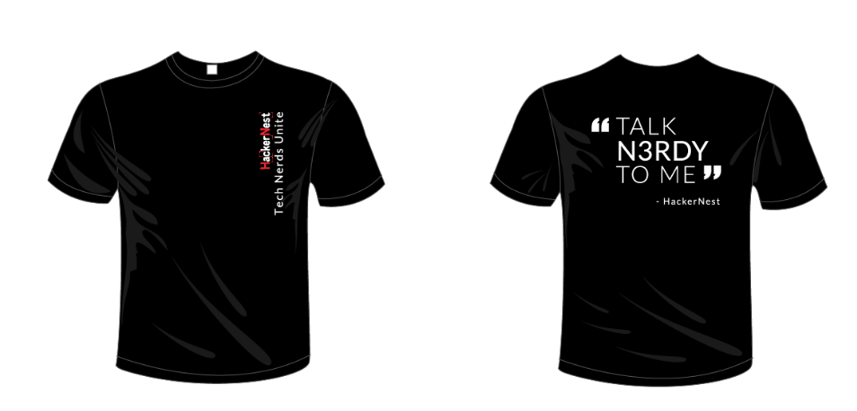

Figure 6.

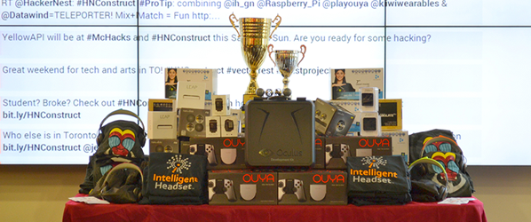

Figure 7.

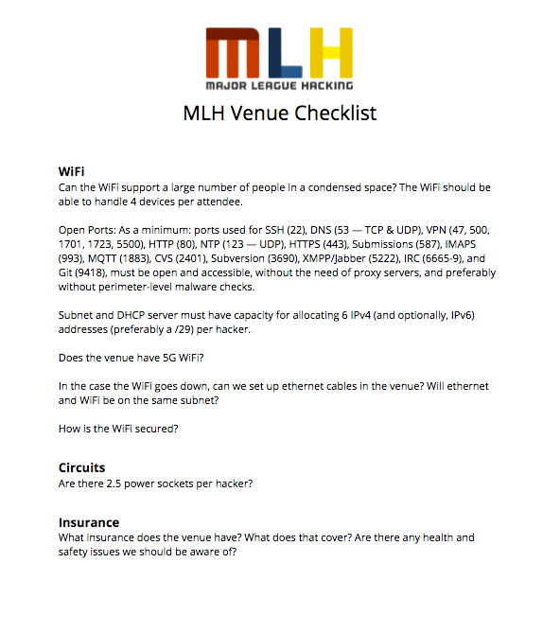

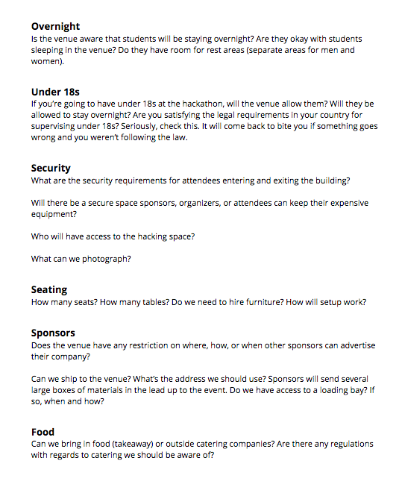

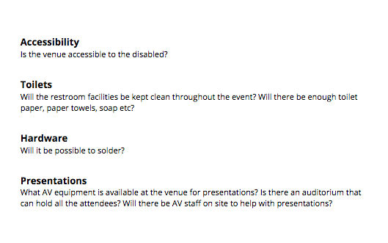

Figure 8.

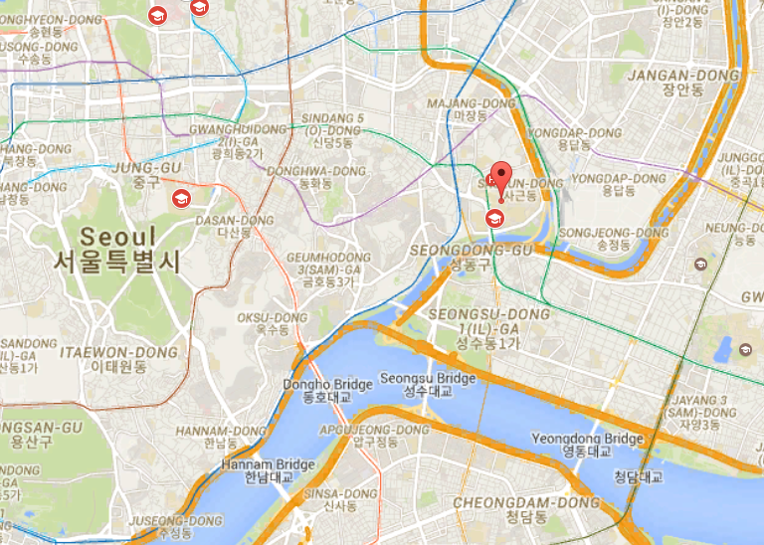

Figure 9.

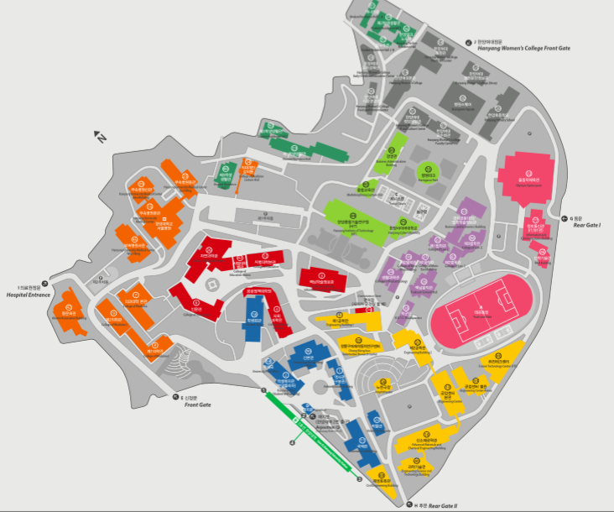

Chung Mong-Koo Automotive Research Centre

Figure 10.

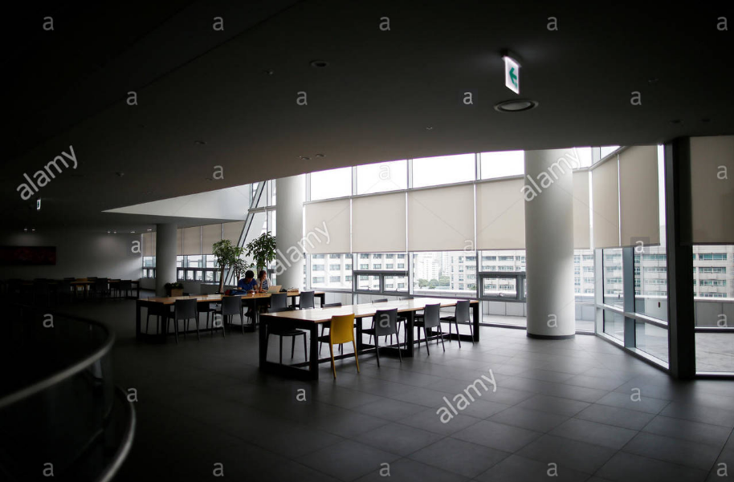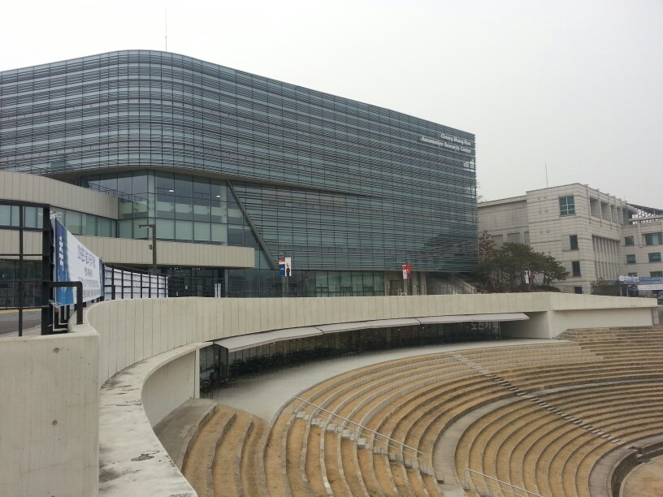

Figure 11.

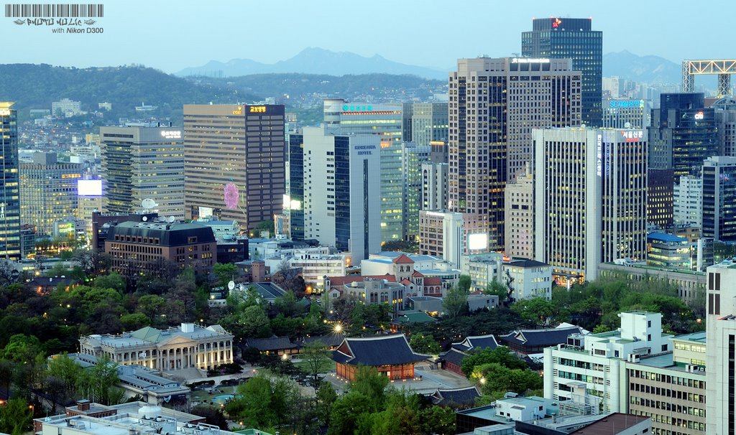

Figure 12.

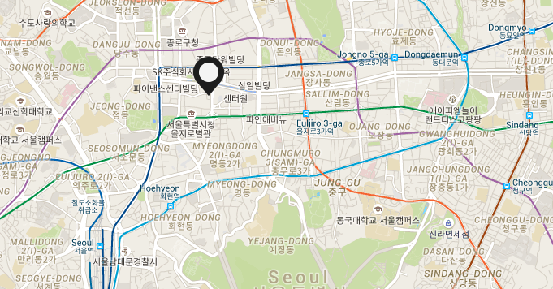

Figure 13.

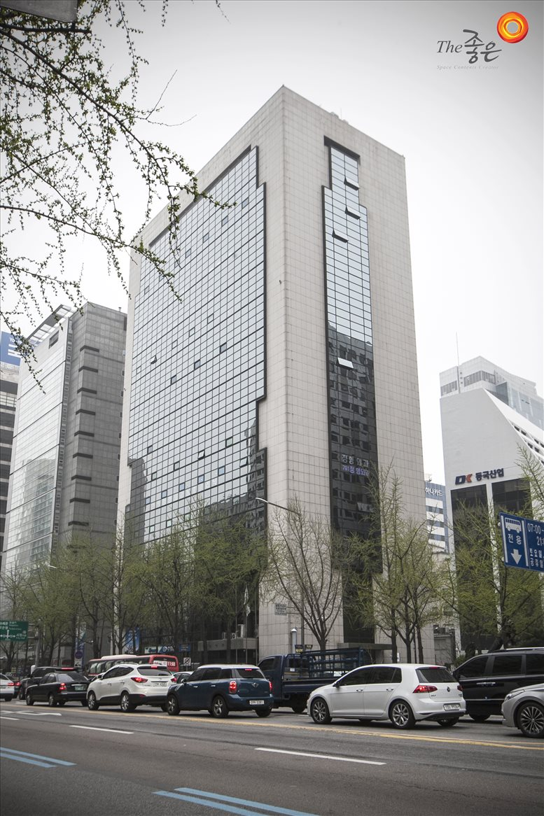

Figure 14.

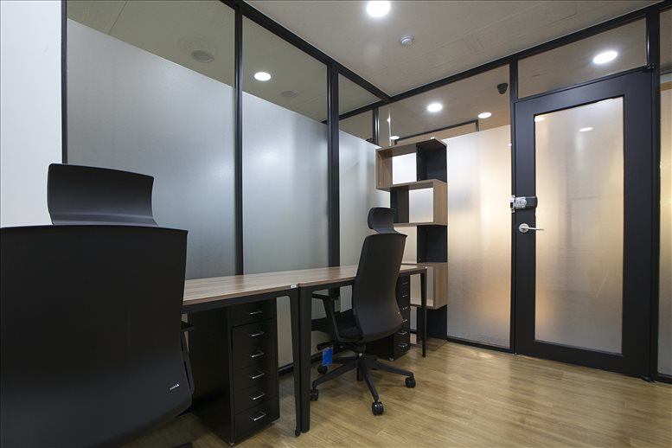

Figure 15.

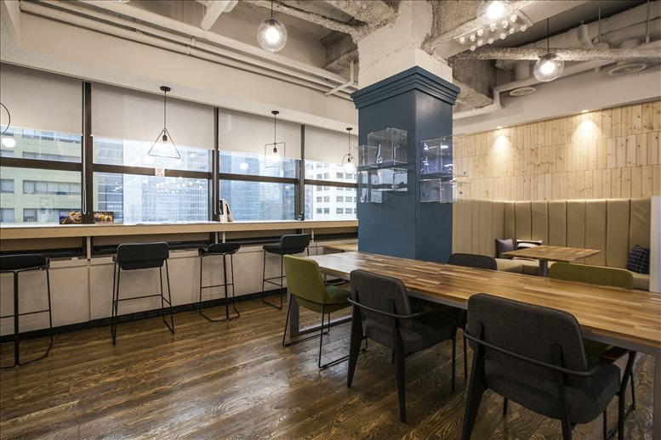

Figure 16.

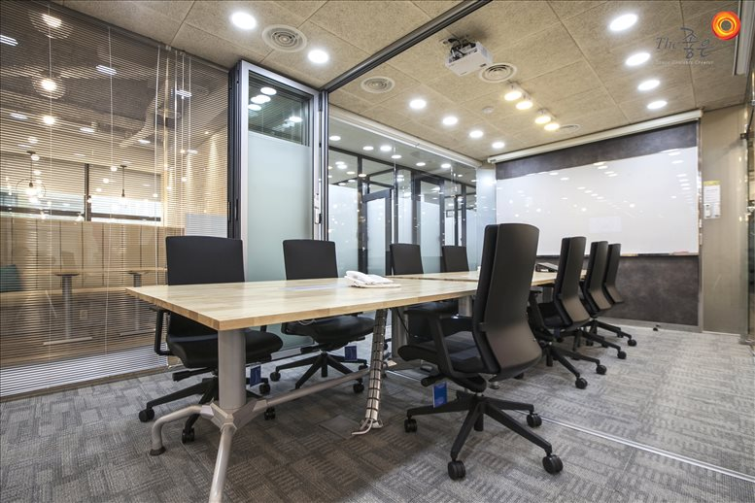

Figure 17.

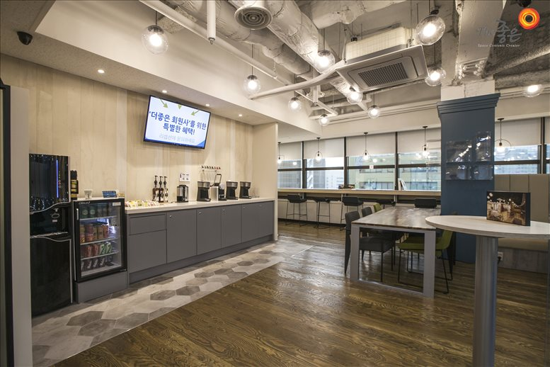

Figure 18.

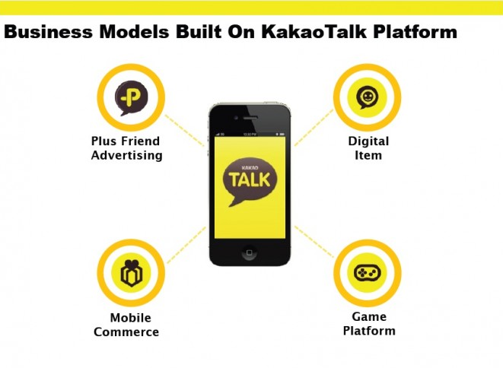

Figure 19.

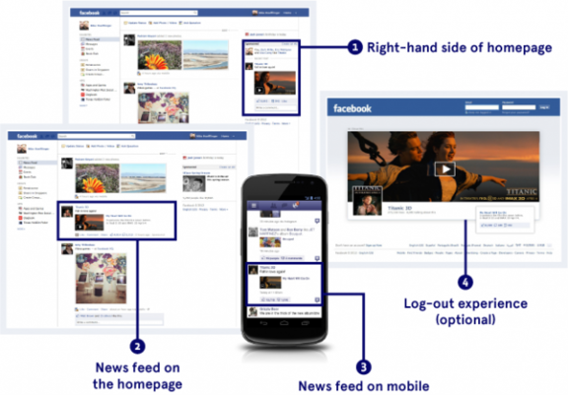

Figure 20.

HackerNest Seoul National University Hack Survey

|  |  |  |  |  |  |
| --- | --- | --- | --- | --- | --- |
|  | Strongly Agree | Agree | Neutral | Disagree | Strongly Disagree |
| The hackathon was well organized |  |  |  |  |  |
| There were enough mentors to provide help |  |  |  |  |  |
| There were enough volunteers to coordinate |  |  |  |  |  |
| There was enough space for work and rest |  |  |  |  |  |
| Food was enough and good |  |  |  |  |  |
| There was enough promotion about the hackathon |  |  |  |  |  |
| Venue was easy to find |  |  |  |  |  |
| I’d like to attend hackathon again |  |  |  |  |  |

How did you hear about this hackathon? ____________________________________________

How old are you? ____________________

Have you been to any hackathon before? If so, how many? _____________________________

How can HackerNest make your experience better?

<http://www.businessinsider.com/world-economic-forum-world-biggest-problems-concerning-millennials-2016-8/#10-lack-of-economic-opportunity-and-unemployment-142-1>

<https://guide.mlh.io/Organizer-Resources/Example-Documents.html>

<http://www.giftypedia.com/South_Korea_Gift_Giving_Customs>

<https://guide.mlh.io/>

<http://www.hanyang.ac.kr/web/eng/campus-map-directions>

<http://www.koreaherald.com/view.php?ud=20150529000776>

<http://www.instantoffices.com/en/kr/available-office-space/seoul/namdaemun-ro-25356>

<http://www.koreaobserver.com/facebook-most-popular-social-media-tool-in-s-korea-poll-62060/>